**Anna Harrington**

**USAToday Bestselling Author**

*Fall into History, Fall into Love*

**About Me**

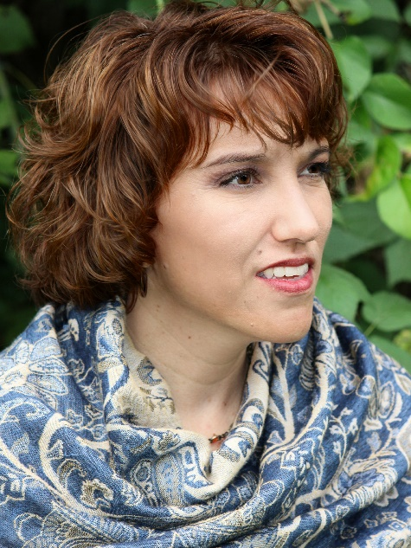I’m a *USA Today* and Indie Reader bestselling author of Regency romances with alpha heroes and independent heroines, layers of emotion, and lots of sizzle. I fell in love with historical romances and all things Regency—and especially all those dashing Regency heroes—while living in England, where I spent most of my time reading Jane Austen and getting lost in London. I have traveled around the world, both as a tourist and as a volunteer with children's organizations in Peru, Ecuador, Thailand, and Mexico. I love to hike and fly airplanes, adore all things chocolate and coffee, and am a Doctor Who fanatic (everyone says my house *is* bigger on the inside!). I am a terrible cook who hopes to one day use my oven for something other than shoe storage. In my spare time, when I'm not writing or teaching, I enjoy ballroom dancing and tending the roses in my garden.

I've been writing since 2015, when All About Romance named me Best Debut Historical Romance Author. My first book, DUKES ARE FOREVER, won the 2016 Maggie Award for Best Historical Romance, and HOW I MARRIED A MARQUESS was a 2017 RITA Award finalist. In 2017, IF THE DUKE DEMANDS won the AudioFile Earphones Award for audiobooks and was a finalist in the Beverly Romance Contest; the book was also named a TOP PICK by Night Owl Reviews and listed as Barnes & Noble’s #1 romance for February, 2017. WHEN THE SCOUNDREL SINS earned a 4-1/2 stars TOP PICK rating by RT Reviews, and Barnes & Noble listed it as their #1 romance for September, 2017. It was also a finalist for the Holt Medallion. Book 4, HOW THE EARL ENTICES, was an Amazon #1 Regency Romance Bestseller, Amazon Top 40 book, and an iBooks Bestseller. My newest series, the Lords of the Armory, launched in February 2020, and book #1, AN INCONVENIENT DUKE was described by *Publishers Weekly* in their starred review as a combination of “suspenseful mystery and charming romance in this compulsively readable treat” and named as one of their Best Books for Spring 2020. In May, 2021, A MIDSUMMER NIGHT’S ROMANCE hit #53 on the USAToday Bestseller List, #5 on the Indie Reader Bestseller List, #53 overall on Amazon, and #19 overall on Barnes & Noble. Most recently, Barnes & Noble named A REMARKABLE ROGUE, book #5 in the Lords of the Armory Series, as a best historical romance of summer 2022.

I can be reached through my website or social media pages at:

Email — anna_harrington@hotmail.com

Webpage — www.AnnaHarringtonBooks.com

All Social Media — www.AnnaHarringtonBooks.com/follow

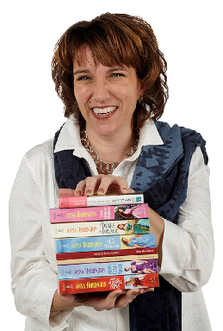

**Book Series**

***The Secret Life of Scoundrels***

The Scarlet Scoundrels of Wellington’s Dragoons have forged a brotherhood while fighting Napoleon that they never thought would be called upon after they laid down their sabers. However, these three war heroes will need each other in order to navigate the perils of returning home and finding love in the most unexpected places.

Book #1 — *Dukes are Forever*

Book #2 — *Along Came a Rogue*

Book #3 — *How I Married a Marquess*

Book #4 — *Once a Scoundrel*

***Capturing the Carlisles***

The Carlisles are back…and England will never be the same! Known as the "Scourge of Mayfair," these men enjoy nothing more than having a good time and striking fear into the hearts of marriage-minded mamas. But when it comes to love, they've finally met their match.

Book #1 — *If the Duke Demands*

Book #2 — *When the Scoundrel Sins*

Book #3 — *As the Devil Dares*

Book #4 — *How the Earl Entices*

Book #5 — *What a Lord Wants*

Book #6 — *After the Spy Seduces*

Book #7 — *If a Lady Lingers*

***Lords of the Armory Series***

Scepter has infiltrated Regency society with the intent of overthrowing the monarchy and plunging England into civil war. The only thing standing in their way is a group of former soldiers who call an old armory building their second home.

Book #1 — *An Inconvenient Duke*

Book #2 — *An Unexpected Earl*

Book #3 — *An Extraordinary Lord*

Book #4 — *A Relentless Rake*

Book #5— *A Remarkable Rogue*

Book #6 — *A Problem Princess*

***The Dukes of Darkness series***

Four best friends turned mercenaries have returned to England, only to be plunged into their fiercest battle yet—becoming dukes. Now forced to navigate the perils of English society, their lives are upended with new obligations and rules they enjoy breaking far more than following.

Book #1 — *The Duke & the Darkness*

Book #2 — *The Duke of Deceit*

Book #3 — *The Duke’s Only Desire*

Book#4 — *The Devil’s Own Duke*



**Contact Information**

For more information, please contact me at:

www.AnnaHarringtonBooks.com

Anna_Harrington@hotmail.com

www.facebook.com/annaharrington.regencywriter

## Praise for Anna’s Books:

"There are authors you follow and there are authors you love, Anna Harrington is an author to love. With a keen sense of history and an intuitive understanding of the human heart Ms. Harrington presents a combination impossible to resist to her readers. It cannot be emphasized enough that this writer is able to effortlessly bring history to her modern readers without compromising the integrity of the period she is depicting with current sensibilities. She portrays strong women even while showing the confines and trials of the time they lived in for realistic stories while still managing to display all the charm and tingles readers would expect from a romance."."   
      ~ Jenerated Reviews

"Harrington's emotionally gripping Regency-era debut, which launches the Secret Life of Scoundrels series, is ripe with drama and sizzling romance...The complex relationship between Edward and Katherine is intense and skillfully written, complete with plenty of romance angst that propels the novel swiftly forward. This new author is definitely one to watch."

*~ Publishers Weekly (Starred Review)*

"Harrington creates fast-paced, lively romances with unconventional characters and plot...There is little doubt that she is fast becoming a fan favorite.

*~  RT Book Review*

"Consider me a freshly minted fan of Harrington’s style of happy ever after."

*~ USA Today HEA*

"If you want to know what romance feels like read an Anna Harrington book.  This author could elicit dreamy sighs in even the most unromantic person in the world as she lovingly doles out tingles and butterflies with her talented pen. Readers will happily surrender to falling in love…"

*~ Jenerated Reviews*